# Project Description

The project described in this document involves smart locks. In particular, for use by elderly or handicapped people entering or accessing homes or other belongings. By completing this project the authors will show a minimum viable product which can improve reliability, be more user friendly and increase security.

## Alternative Products

A digital door lock system is equipment that uses the digital information such as a secret code, semi-conductors, smart card, and finger prints as the method for authentication instead of the legacy key system (Park, 2009). As such, the proposed method will involve an RFID Card, for user authentication, and a motor module, to open and close the door lock.

This is in contrast to the hundreds of smart locks currently on the market, most of which either link to a smart phone or require a touchscreen and individual pin code (Prospero, 2017). The advantage of having such a system as an RFID and motor is that it does not require a new dead lock configuration. This can be simply added to the current locks installed. Furthermore, the time and cost in setting up an external RFID lock package is significantly less than those currently found (Scalisi, 2015).

## Problem Statement

In order for the smart lock project to be valid we must find an answer to the question “Can a swipe card be used as an alternative to a key to enter a home?”

## Hypothesis Question

In order to assess whether a smart lock can substitute for a standard key and lock fixture the authors proposed that the lock will be able to distinguish between different RFID cards to turn the lock. This is an important aspect of this design, as if the lock opens on all cards, the method cannot be accepted. This is further broken down into several research questions, being:

1. Can the Arduino system read different RFID tags?
2. Can the tag allow the lock to open and close?
3. What is the effective range of the card reader?

By addressing these questions we can prove or disprove the application of RFID Smart Locks within the home.

# Approach

## 2.1 Technology

In order for the build to be effective it has been identified that several pieces of equipment are required for the proof of concept. These are:

1. Arduino Uno, the thinking component used to link all pieces together.
2. RFID reader, the sensing component used to acquire relevant data
3. 5v stepper motor, the acting component used to open the lock to the door
4. RFID Card, used to enact a series of events based on coding
5. Data Logging shield to capture entry information

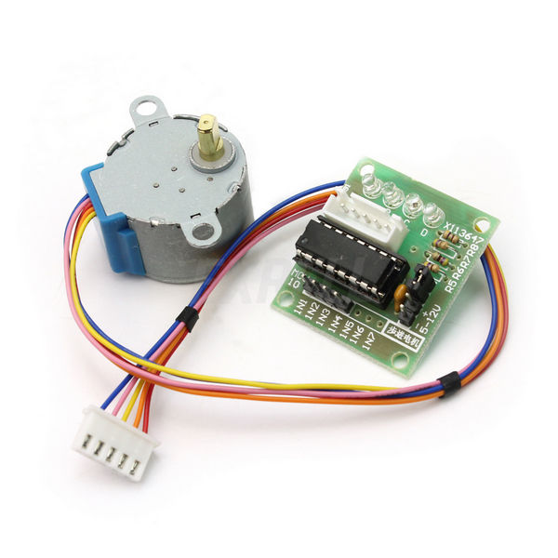

Figure 1 - 5V Stepper Motor

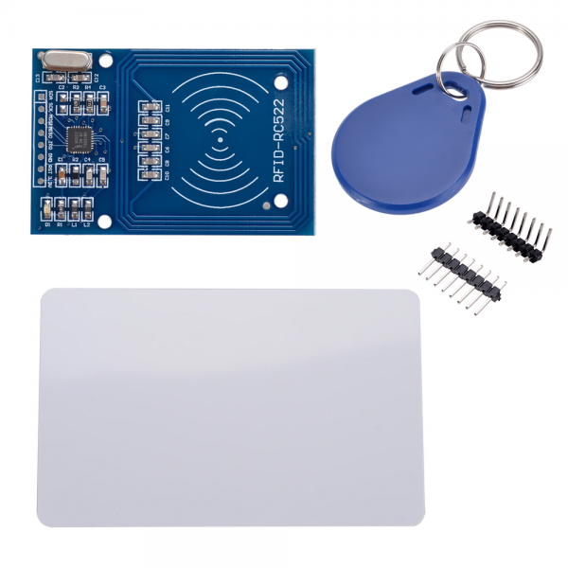

Figure 2 - RFID Card and Reader

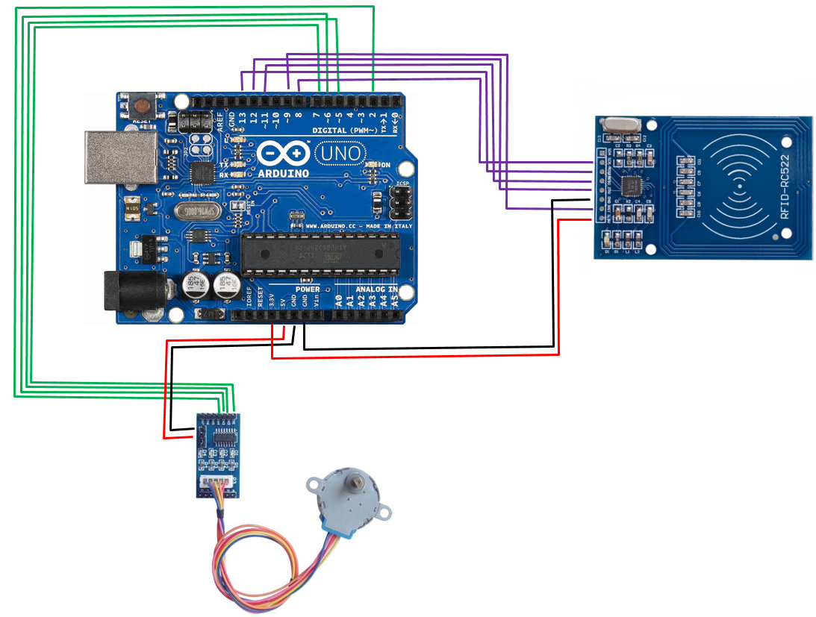

Figure 3 - Final Schematic

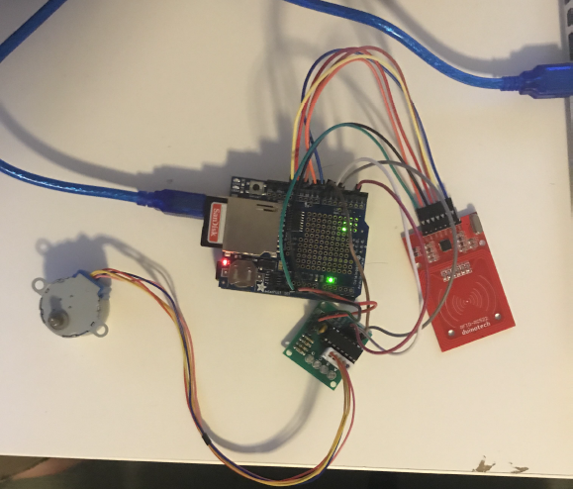

Figure 4 - Actual Setup

## 2.2 Arduino Pin Layout

5V stepper Motor:

* INT 1 = Digital Pin 7
* INT 2 = Digital Pin 5
* INT 3 = Digital Pin 6
* INT 4 = Digital Pin 2
* Power = 5V (Arduino Board)

RFID Scanner:

* MOSI = Digital Pin 11
* MISO = Digital Pin 12
* SCK = Digital Pin 13
* SDA = Digital Pin 8
* RST = Digital Pin 9
* Power = 3.5V (Arduino Board)

It was discovered that this was the optimum layout. This is due to the fact that some of the pins were crucial to the libraries working effectively.

# Code

The code for the project can be found in the Github Repository:

<https://github.com/lachlanmcinnes/Project/blob/master/RFID_EXAMPLE_v3.ino>

(Please note this is old. NEEDS TO BE UPDATED!!!)

# Data Collection

## Can the Arduino system read different RFID tags?

With the RFID system used within this project, each card has 5 unique serial numbers, ie. Serial_array[ ][5]. In order to test whether the system could distinguish between different RFID cards 2 separate cards were used over the reader and monitored the serial. The following data was displayed, rounded to the nearest 5 minutes.

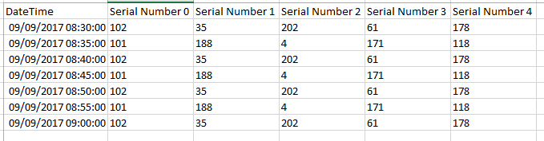

Figure 5 - Data for Experiment 1

This data clearly shows that the reader is deciphering 2 separate sets of serial numbers accurately. This then shows that the first problem can be overcome.

## 4.2 Can the tag allow the lock to open and close?

Once discovered that the reader could recognize different tags a test was conducted to establish whether the separate cards would activate the 5V stepper motor. First Card, Serial Number 0 as 102, was created as the Unidentified card. This would not allow the motor to turn. The second Card, Serial Number 0 as 101, was created as the owner. A series of trial scans then showed whether or not the motor would turn.

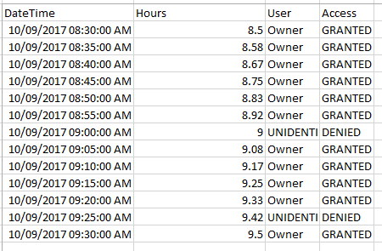

Figure 6 - Data for Experiment 2

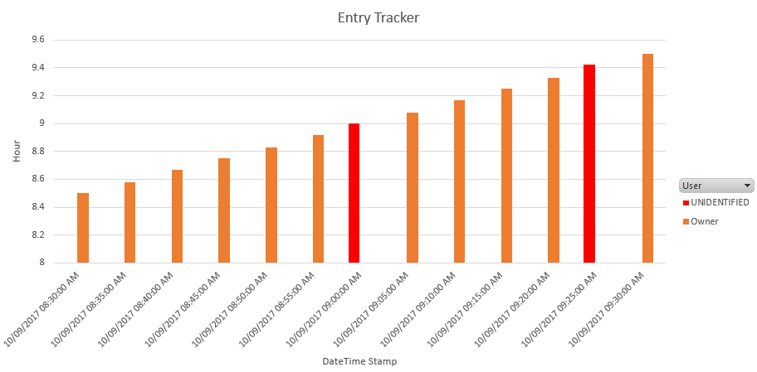

Figure 7 - Display of Data Experiment 2

This data, shows the different cards being swiped and either being accepted or rejected by the smart lock system. This data was further backed up with visual inspection. Whenever card 1 was used, motor did not turn. Card 2 however allowed the motor to open and close.

## What is the effective range of the card reader?

A test was run to see the effective distance the reader could gather information off the different cards. This was completed by swiping the cards above the reader at different heights, in 0.5cm increments. A 1 was given if the data was captured, and a 0 was given if there was no recorded data.

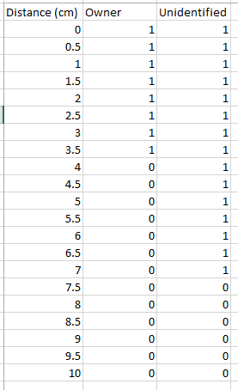

Figure 8 - Data for Experiment 3

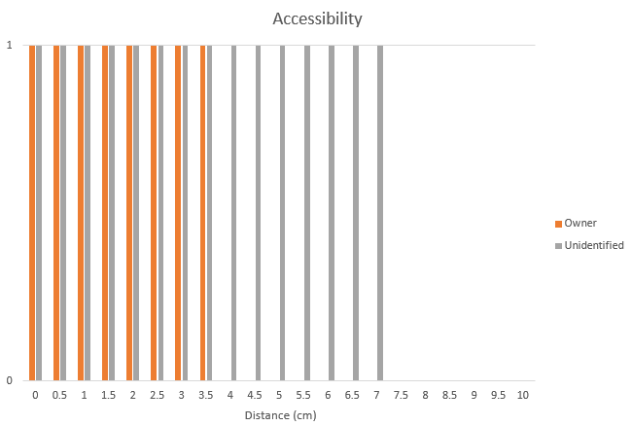

Figure 9 – Display of Data for Experiment 3

# 9.0 References

Yong Tae Park, et al. (2010). *Smart digital door lock for the home automation*

Singapore: IEEE

Joseph Frank Scalisi (2015). *Smart lock systems and methods*

America: US Patent Office

Mike Prospero (2017). *Best Smart Locks*

https://www.tomsguide.com/us/best-smart-locks,review-3352.html